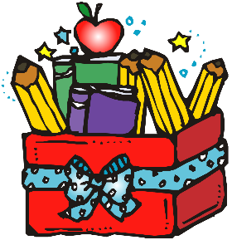Berclair Elementary 3rd Grade Supply List 2024-2025

* 1 pair of durable headphones (to leave at school)
* 1 pack of Elmer’s glue sticks (**NO LIQUID GLUE**)
* 1 box of 24 count Crayola crayons
* 1 box of Crayola Twistable Color pencils
* 1 pair of scissors
* 3-4 boxes of Kleenex
* 1- 3 ring pencil pouch (**NO PENCIL BOXES**)
* BOYS: 1 box of gallon ziplock bags
* GIRLS: 1 box of quart ziplock bags
* 2 boxes of **Ticonderoga** wood pencils
* 4 plastic folders with brads and pockets (1 red, 1 blue, 1 yellow, 1 green)
* 1 container of disinfectant wipes
* 1 pack of dry erase markers
* 2 composition notebooks (**NO SPIRAL NOTEBOOKS)**
* 1 pack of graph paper
* 2 packs of 3x5 index cards
* 1 steno pad

WISH LIST

* 1 roll of paper towels
* Treats and small toys for classroom treasure chests
* 1 pack of cardstock (white or color)
* 1 box of band-aids